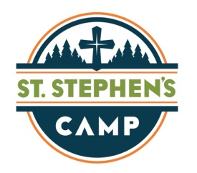

SUGGESTED PACKING LIST

ORTHODOX STUDY BIBLE
Appropriate clothes, as outlined above. We suggest a minimum of (10) t-shirts & (6) pairs of shorts. {There are no laundry facilities available at summer camp.}
Underwear
Socks
Swimming Suit {see requirements above}
(2) Pairs of Tennis Shoes
Hiking or Outdoor Sandals {with some support – no flip flops}
Shower Sandals
Rain Gear
(2) Towels – one for showering & one for swimming
Toiletries (including soap, shampoo, conditioner, toothbrush, toothpaste, dental floss, comb, hairbrush, deodorant, feminine hygiene products)
Hat and sunglasses
Sleeping Bag or Twin Sheet Set + pillowcase {pillow & blanket provided}
Bags for dirty clothes & wet clothes
Sunscreen
Flashlight
Bug Spray
Sweatshirt and/or Light Jacket

ADDITIONAL ITEMS:
Gatorade / Water – if desired {refrigerator is available in each lodge}
Individually Packaged Snacks
Instrument or Props for Thursday evening Talent Show
White T-Shirt, Pillowcase, or Socks for Arts & Crafts project

DO NOT PACK:
- Any electronic devices, including, but not limited to: cell phones, iPod, iPad, mp3 players, tablets, laptops, DVD players, video games, etc. If brought to camp, these devices will be collected during on-site check in and returned at the conclusion of your session. Any electronic devices found after on-site check in will be confiscated and the camper disciplined.
- Sodas, sugary drinks, coffee drinks, or energy drinks. If brought to camp, these will also be collected during on-site registration and returned at the conclusion of your session.

PROHIBITED ITEMS:
- Alcohol
- Cigarettes (including E-Cigarettes)
- Illegal Substances
- Weapons of any type, including pocket knives
- Incendiary Devices (such as lighters or fireworks)

Possession of any of the above mentioned items, or any illegal substance, will result in immediate removal from the grounds and the St Stephen’s Camping Program. Individuals will be sent home at their own expense.

