Soar to New Heights / Elevate your Faith / Expand your Knowledge
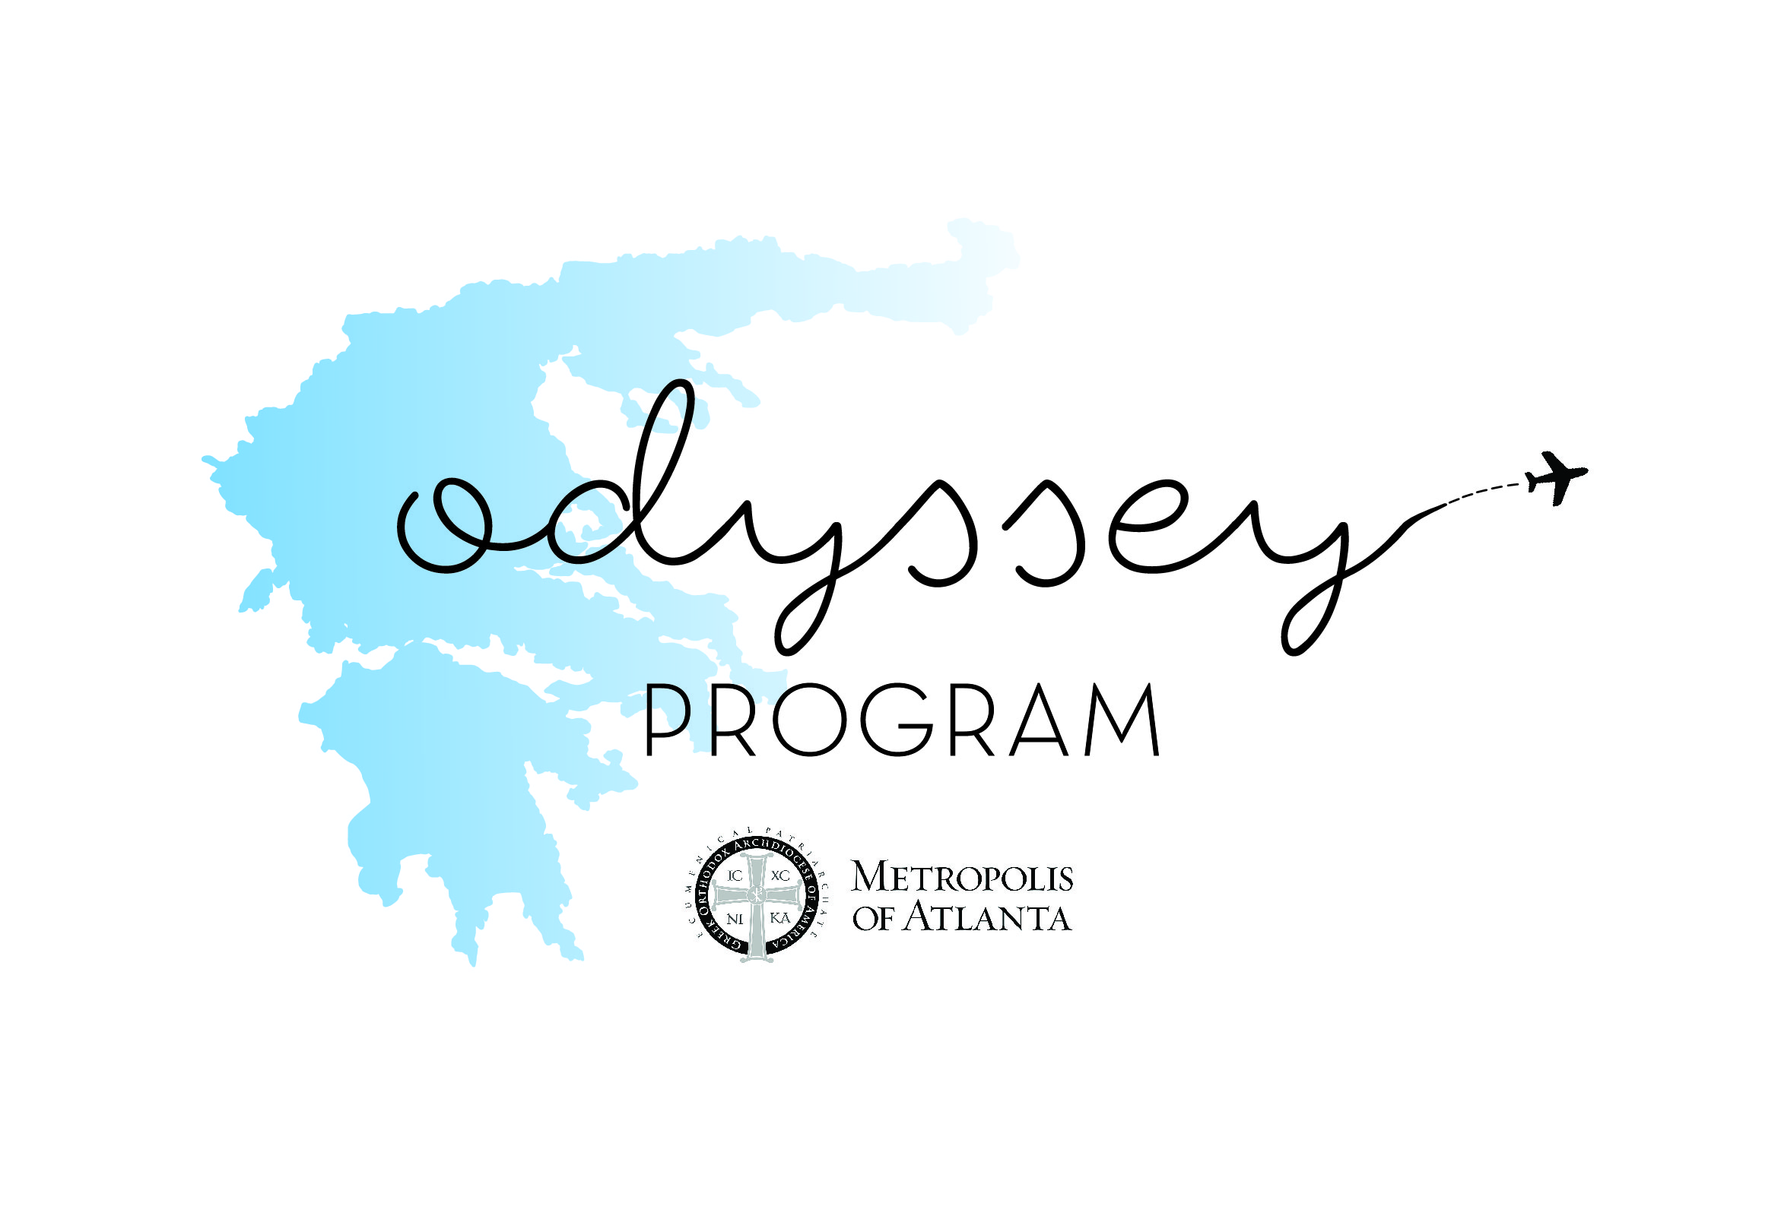

As part of the application process for our 2018 Dancer Odyssey Travel Program, all applicants are required to submit a 5-7 minute video on one of the approved topics below. Dancers are encouraged to be as thorough as possible, while expressing their individuality, knowledge of the topic, resourcefulness, and creativity. In addition, a complete bibliography must be included, either electronically at the end of the video or in hard copy directly to the Metropolis of Atlanta.

2018 TOPICS
+ Choose a specific Feast and describe how it is celebrated in a typical Greek Village
+ The role of Greek Immigrants in my home parish & city
+ How the Orthodox Faith was maintained during the Turkish Occupation
+ Discuss the life, commemoration, and village celebration of my Patron Saint

All submitted videos are retained by the Metropolis of Atlanta and may be used in future events or advertisements for the Hellenic Dance Festival Weekend, Odyssey Scholarship, or other Hellenic Culture activities.

VIDEO SUBMISSION DEADLINE: Friday, November 30th at 6:00pm

